“Get a job, Ken!”
by Kenneth Hanson | Uncategorized |

It has been several months since my last post, but I have (what I think is) a reasonable excuse: I’ve been trying to get a job. The demanding mantra endlessly looping in my brain for the last six months was, “Get a job, Ken!” Applying for chemistry faculty positions at R1 institutions has been a trial both scientifically and emotionally, especially since the likelihood of landing such a job is increasingly the exception rather than the norm. I’ve very glad my search is over and I humbly and yet happily share that I will be starting as an assistant professor at Florida State University in the fall (August 2013).
Reflecting on the job search, I found that there were very few resources that helped me understand what to expect beforehand. This is probably especially true for someone like me who did not come from institutions more traditionally known for producing professors, like Cal Tech, MIT, and Berkeley. I did not spend my undergraduate and graduate years observing and learning from older coworkers/friends going through the faculty job search process before me. To my surprise, I also found little online about the chemistry faculty job search and what makes it different from other job searches. Instead, I spent a lot of time gleaning hints and tips from coworkers, advisors, professors and anyone that would answer my questions. Hoping to help those entering the search after me, while also building on previous blog posts where I share advice for new graduate students and post-doc position seekers, my next series of blog posts will outline my faculty job search experience.
Most of the advice I’ll share is based on my own anecdotal experiences or the stories I’ve heard from others. These experiences vary widely and, when preparing for your own job search, I encourage job seekers to consult with as many people as possible and load-up on advice. I also hope others will share more in the comment section. Another thing to note is that my experience was specifically with faculty positions relating to materials, inorganic, and any energy related research. Yet, even with this emphasis, it’s possible that many of the suggestions are still applicable to primarily undergrad or even an industry job-seeker. Since I find myself with so much to share (as well as hesitant to ask readers to read a mega-post all at once) I am going to partition the “Get a Job, Ken!” experience into the following posts covering eight different aspects of the job application process:
- The Timeline
- Proposal Preparation
- Proposal Format
- Other Content
- Submitting and Waiting
- Phone and On-site Interviews
- Research/Proposal Talks and Meeting with the Chair
- The Offer, Second Visit, and Negotiation
I hope you find them useful.
2. Proposal Preparation
In my last post I describe the timeline for my faculty job search. In this post, the second in the “Get a job, Ken!” series, I share my strategy for creating and vetting research proposal ideas.
The academic job application consists of a number of items. Most universities ask for a cover letter, CV, letters of recommendation, research proposals, and occasionally other materials (like a teaching statement). A candidate’s appeal to the search committee often depends on the presentation of his/her previous accomplishments (which I’ll discuss in the posts that follow) and, perhaps more importantly, research proposals.
Very few job posts provide guidelines for proposals. My understanding is that search committees want to see two or three original research ideas that are:
- Different from the work of previous advisors.
- Unique enough to show creativity and the ability to compete with others in the field.
- Interesting enough to be potentially fundable.
Many people, me included, encourage those planning to apply for faculty positions to start thinking about original research ideas while in graduate school. Thinking about proposals early allows time to work through ideas as well as build a broad knowledge based about cutting-edge research. Not everyone will come up with a new, creative idea while in graduate school, but it’s helpful to start practicing and developing the strategies to do so early.
One strategy to fuel the creative process includes learning about research outside of your immediate field. While reading papers or walking though poster sessions, ask yourself: “How could this research contribute to my work?” and “How could my expertise contribute to their work?” Many major research advances bridge the gap between sub-disciplines. Gap-bridging ideas also have greater potential to appeal to more members of the search committee. Most academic hires are decided by entire departments, representing individuals from all ‘flavors’ of chemistry.
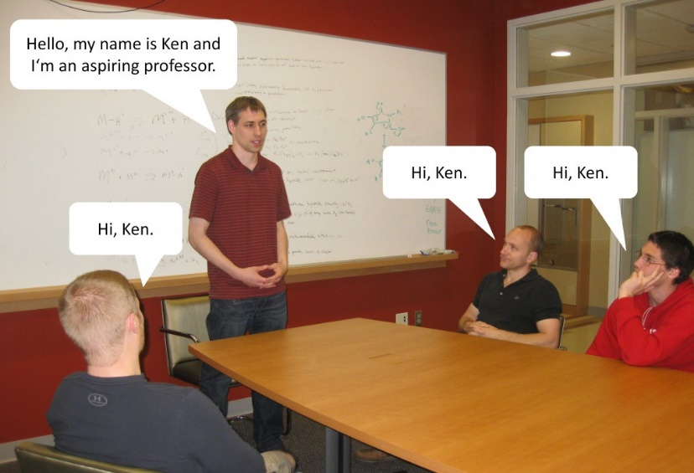
Quick aside: be cautious when getting excited about a new idea. It is very disappointing to come up with a ‘new idea’ and then discover after a literature search that someone else has already published it. Yet, this unfortunate event has a silver lining. It suggests you’re on the right track to coming up with feasible/publishable ideas.
Coming up with new ideas is difficult. There is also a large activation barrier to formalizing new ideas and writing them as a research proposal. There are many strategies to start and maintain the process, such as establishing incentives, deadlines, punishments, etc. In contrast to these self- dependent and willpower-driven strategies, I found joining/creating an Aspiring Professors Support Group especially helpful.
Our Aspiring Professor Support Group was composed of individuals interested in applying for academic jobs (either in 2012 or beyond) in various domains of chemistry, including organic, inorganic, analytical, and physical. The members of the support group respected and trusted each other – an important factor. We were comfortable sharing our ideas and there were no concerns about anyone stealing and misrepresenting other’s ideas as their own. Once the support group was formed, we set up meetings—with deadlines—for presenting our research ideas.
We began meeting once a week in early July, 2012. At each meeting three people gave either a chalk talk or power point presentation on one proposal idea (6 people x 3 proposals each = 18 proposals over 6 weeks). Scheduling the presentations gave us a tangible deadline and forced us to think through and prepare our proposals before job applications were due.
These meetings served as the first filter, outside of our own minds, to gauge whether we should commit to writing down a particular proposal. We presented and defended our ideas in front of an audience and if there were fundamental flaws with a proposal—like infeasibility or impossibility—they were abandoned or revamped. The diversity of our Aspiring Professors Support Group also proved an important opportunity to see how chemists from other areas/domains responded to each idea. The group’s questions helped prepare me for the questions I might be asked during an actual interview.
In addition to formalizing ideas, the group was also helpful in other aspects of the job search. We sent new job openings to each other and shared anecdotes/stories/advice for the application process.
Continuing my “Get a job, Ken!” series, this post builds upon the last by suggesting how to turn research ideas into written proposals.
3. Proposal Format
Strong proposals contain a competitive research idea (as discussed in my previous post), clearly communicate the idea, and concisely propose a plan to pursue it. The plan being the materials, measurements, expected results, and potential complications you may run into while attempting to turn the never-before-implemented idea into something real. Finally, strong proposals sell the idea by explaining why it’s unique, scientifically significant, and attractive to funding agencies.
A large majority of job openings do not specify a page limit for the proposal component, but I followed the advice of several friends and Professors to keep it at or under 10 pages. In these ten pages I included a cover page, three proposals (at three pages each), and one page of references. Below I break down each of these sections in greater detail.

The Cover Page
The search committee members will be bombarded with hundreds of applications. They simply will not have time to read through a three, let alone ten, page proposals from every applicant. I’ve heard from a few professors that they do not look at CVs or recommendation letters until the candidate list is whittled down based on the first page of the proposal alone. The cover page may be the deciding factor between making it through the first round or being cut. This is why it’s very important to spend a lot of time making a clear and compelling cover page.
The general format I used for my cover page can be seen in the image below. Forgive me for not sharing my actual proposal cover page. I haven’t had the opportunity to pursue the ideas yet.
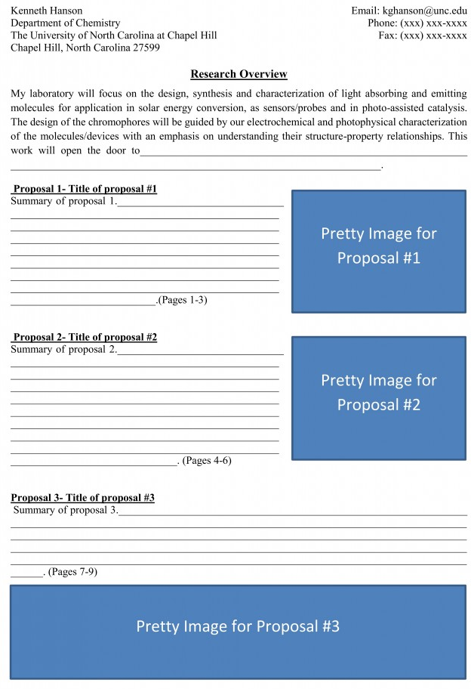
As shown in the image, my cover page included:
1) My name and contact information at the top of the page.
2) A Research Overview, explaining my flavor of research and what I’ll be known for in five years if given the chance to pursue my proposals.
3) A subsection for each proposal that included:
- A title
- Page numbers
- A brief summary, which was structured similar to an abstract. It introduced a problem to be solved, how I intend to solve it, and the potential implications.
- A pretty image depicting the research idea.
The images accompanying each proposal might be the most important part of the cover page. They should be descriptive, aesthetically pleasing, and eye catching. The goal is to get the search committee curious enough about the ideas so they will look through the proposals and other application materials.
The Proposals
Each proposal should be three pages or less. Since the faculty search committee may include a broad range of chemists, you should try to limit the use of jargon and not assume too much prior knowledge about your research area. Compressing this information into three pages or less sounds like a monumental task and, to be perfectly honest, it is. It will take a lot of time and effort to put a short but solid proposal together. In an effort to help, below is a generic form of my proposal format.
As shown in the image, each of my proposals were organized into the following three sections:
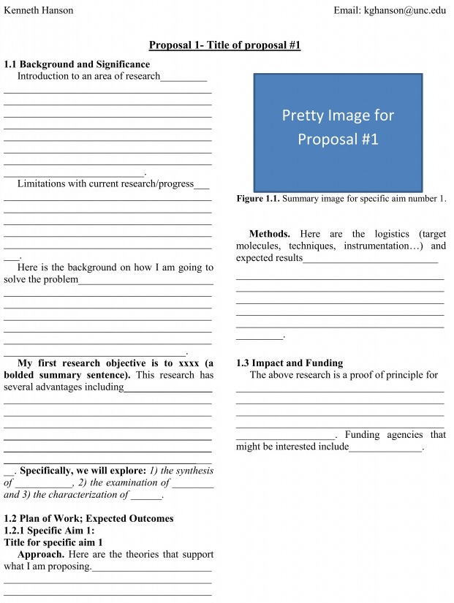
1) Background and Significance
- Introduce a problem that needs to be solved.
- Describe how others are trying to solve it.
- Describe how I am going to try to solve it.
- Discuss how my method is better.
In this section, I included one bold sentence that clearly summarized the nature of my proposal and an italicized sentence outlining a few specific goals.
2) Plan of Work
- Explain the logistics of how you’ll pursue your idea (i.e. the materials, measurements, expected results, and potential complications).
3) Impact and Funding
- Remark on the potential implications of the proposed work.
- List a few potential funding agencies.
When mentioning funding agencies be very explicit. Include the agencies (NSF, NIF, DOE, ARO, etc.) as well as the divisions and sub-divisions within the agencies. An easy way to find possible funding agencies is to look at the acknowledgements section of the papers cited in your proposal. Chances are you will be applying to the same funding opportunities.
Example: “The importance of solar energy conversion research in our current economic and political climate leads me to believe my research program will appeal to both students and funding agencies like the National Science Foundation (CHE/MSN, DMR/SSMC) and Department of Energy (BES/MSE, CSGB).”
Citations
I made sure to fit all of my citations on one final page to keep the total page count at 10. As far as citation format, I went with ACS standard formatting but others might work just as well.
Other Formatting Notes
Although some people choose a one-column format, I decided to go with two columns because it is more analogous to many journal articles and, for me, feels easier to digest. I also made sure to include at least one pretty picture per page. It breaks up the wall of text.
Proofreading
I started drafting my proposals early (June or July) so I had time to play around with and re-write the text many times. Maybe more importantly, the time also allowed others to proofread what I’d written. Our aspiring professor support group (described in “Get a job, Ken!” Part 2) was particularly useful for proofreading. We set up an editing rotation: I shared each of my proposals with three different people for feedback. I also read nine proposals from six different people.
After the aspiring professor support group’s initial screening and revisions, I also asked for comments/suggestions from several professors who had either been on a hiring committee before or just went through the job application process. This included my previous advisors and several Profs. at UNC. They were a big help because they let me know what they found compelling and memorable as well as where I could improve. Finally, I turned outside of the chemistry world to people like my wife to proofread for language and spelling errors.
In the next blog post I’ll share a similar breakdown for the other application materials

